Press Release
July 20, 2020
Aoyama Design Forum

Call for Entry! ADF Milano Salone Design Award 2021
The design theme is “re_”

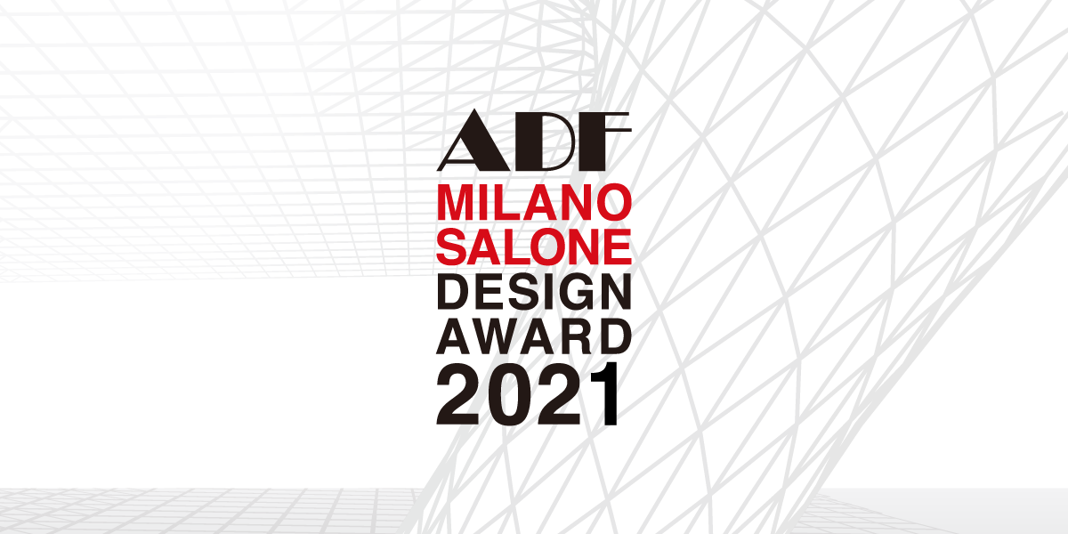

Non-profit organization ADF has decided to showcase at “Fuori Salone” during the Milano Salone, the International Furnishing Accessories Exhibition, held in Milan, Italy, in 2021. The showcase will go on during the exhibition. ADF will invite the design worldwide for the “ADF Milano Salone Design Award 2021”. The registration is now open until November 15, 2020.

The theme of this year’s “ADF Milano Salone Design Award 2021” is “re_”. “re_” literally means “to make something again”. ”re-BORN“ “re-CYCLE” “re-USE” “re-BUILD” “re-NOVATION”... Propose your own “re_” in your own way. Furniture, architecture, space, plan... The format is open. Don’t miss this great opportunity to send your wonderful ideas and works out into the world, at the world’s famous exhibition, “Milano Salone”.
“ADF Milano Salone Design Award 2021” Entry: https://pro.evalato.com/2455
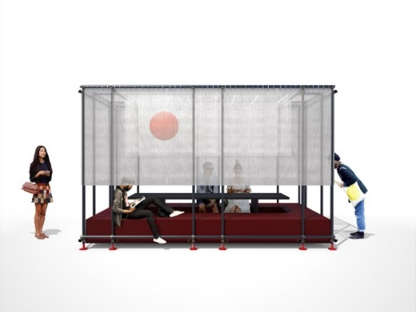
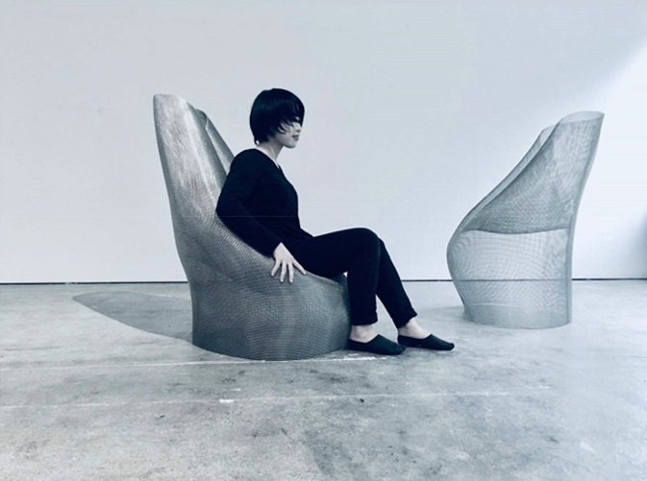
2020 award-winng work, “CYLINDER × MATERIAL"
by Rie Aruga

2019 award-winning work, “TOMI” by Foro Studio

ADF (Aoyama Design Forum) is a non-profit organization established in Japan in 2009, and we aim for training and improving the status of designers worldwide. Since our establishment, we have been working closely with many design and architect associations throughout the world. As part of that, we have been showcasing at the “Milano Salone” since 2013, which is held once a year in Milan, Italy.
We are pleased to hold our award, “ADF Milano Salone Design Award 2021”. By receiving many entries from all over the world through our partner organizations every year, this award has been growing as an international competition for product design.
ADF : https://www.adf.or.jp/english/

The design theme is “re_”. Winner’s work will be exhibited at the “Milano Salone”!

“re_” literally means “to make something again”. ”re-BORN“ “re-CYCLE” “re-USE” “re-BUILD” “re-NOVATION”... Propose your own “re_” in your own way. Furniture, architecture, space, plan... The format is open.

From all of the entries based on the award theme, three works (1 Best Performance Award, and 2 Outstanding Performance Awards) will be chosen under strictly impartial examination. The Best Performance Award winner will receive a prize of 10,000 USD and will be bestowed to exhibit the award-winning work at the ADF booth of the “Milano Salone” held in 2021 as an extra prize (ADF supports up to 10,000 USD separately as production and construction expenses). The exhibition site is located in the Zona Tortona that is known as the most popular place in the “Milano Salone” off-sites. We are looking forward to receiving unique entries.

Judging Criteria：

- Innovation
- Originality
- Extensibility
- Functionality
- The space creates communication friendly environment

Juries:

TBA

Award:

- Best Performance Award 1 work Prize： 10,000 USD / Extra prize: Exhibit the award-winning work
- Outstanding Performance Award 2 works Prize： 1,000 USD

Exhibition Booth:

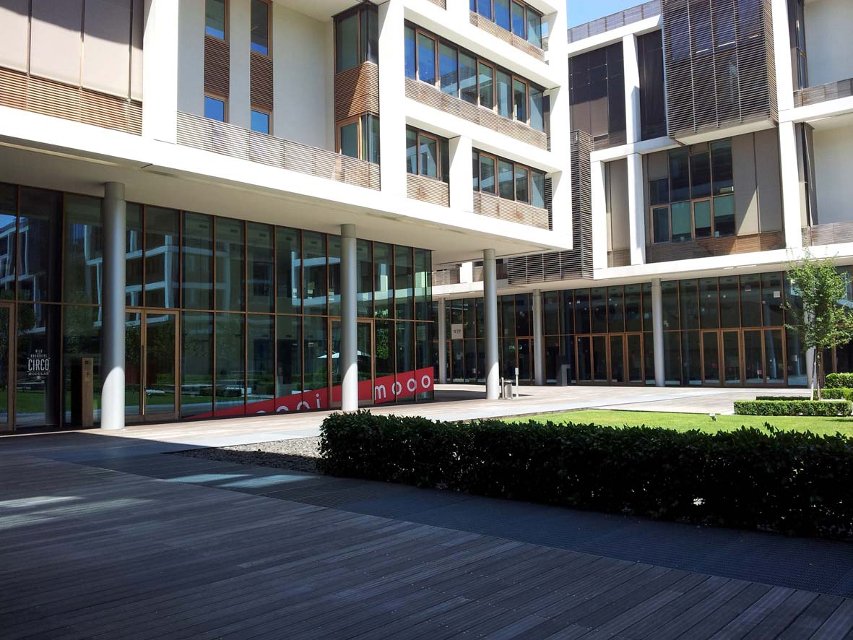

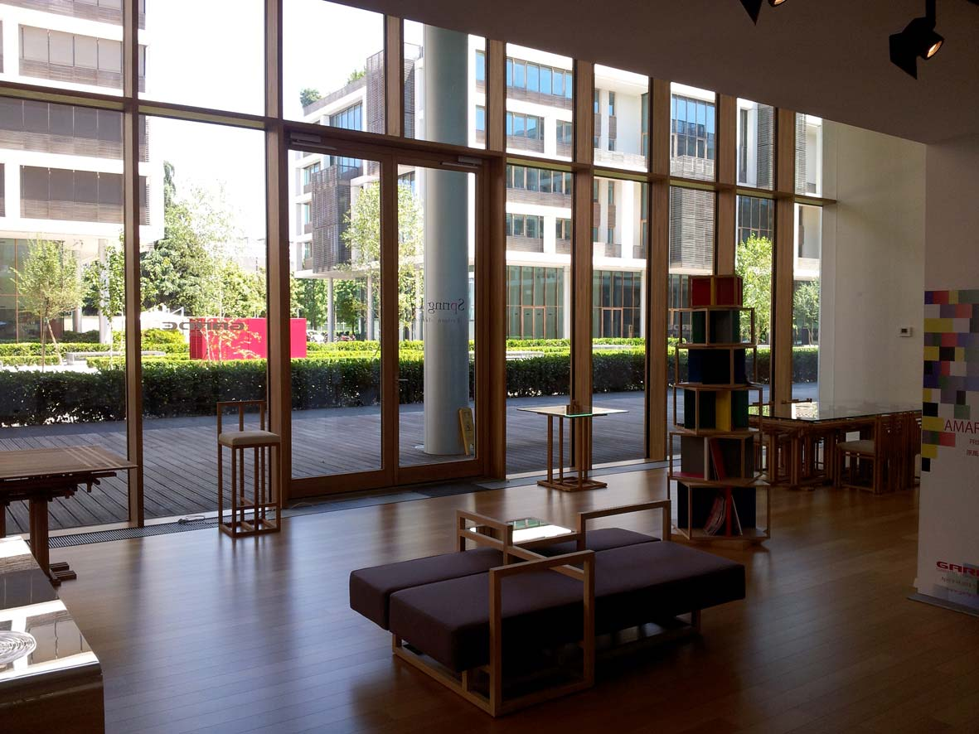

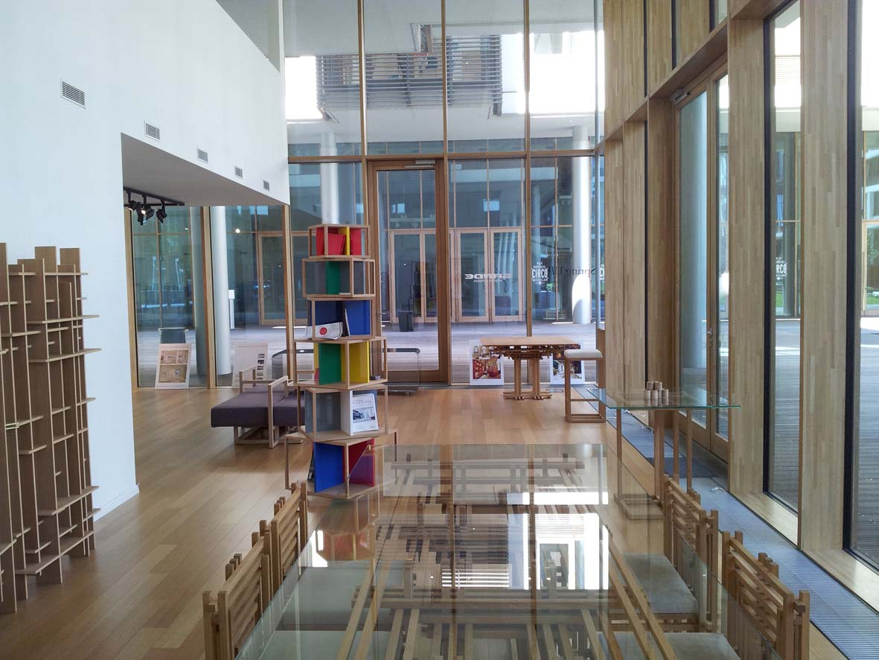

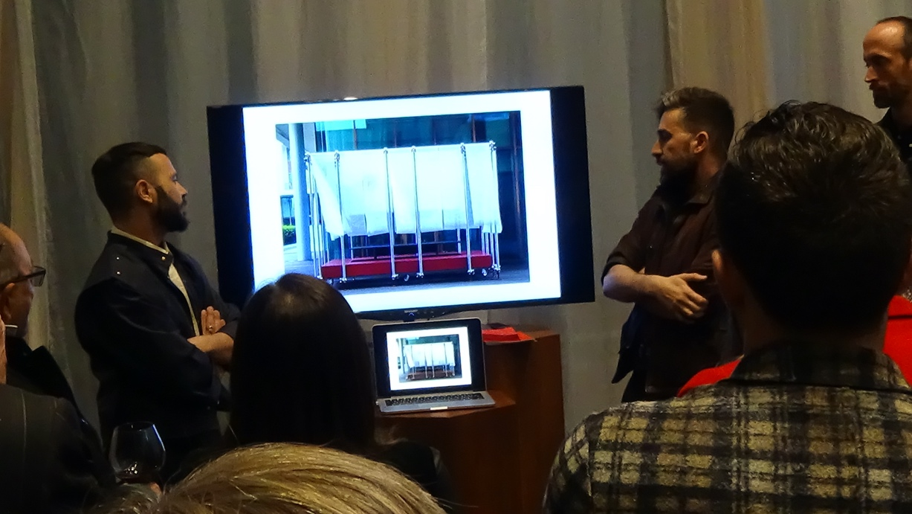

Winner’s Announcement:

January 25, 2021

”ADF Milano Salone Design Award 2021” Summary

Title | ADF Milano Salone Design Award 2021
Design Theme | “re_”
Period | July 1 – November 15, 2020
Awards | Best Performance Award – 1 work, Prize：10,000 USD  Extra prize: Exhibition of the award winning work  (ADF will sponsor for the production and site installation cost up to 10,000 USD  for the Best Performance Award work)  Outstanding Performance Award - 2 works, Prize：1,000 USD  ※There is a case of no corresponding work awarded.
Qualification Requirements | Individual or group (1 project per group)  Regardless of nationality
Application Fee | Free
Application Language | English or Japanese
Details | https://pro.evalato.com/2455

About the “Milano Salone”

The Milano Salone, a common name for the International Furnishing Accessories Exhibition, is a furniture fair held annually in Milan. It is the largest trade fair of its kind in the world. The exhibition showcases the latest in furniture and design from countries around the world. It is considered a leading venue for the display of new products by designers of furniture, lighting, and other home furnishings.

It was launched in 1961 with the aim of promoting the export of Italian furniture and interior products. The exhibition becomes “international” from 1967, and has been called “SaloneSatellite” from 1998 on. There is a voluntary exhibition by young designers who passed the advance screening, which became to be known as a gateway to becoming a successful designer. After the 90’s, there are more and more voluntary exhibitions held in Milano during the Milano Salone. These exhibitions started to attract the concerned parties who gather to Milano Salone, which became to be called the Fuori Salone, meaning “outside of Salone”. Today, Fuori Salone is held all over Milan, from where many famous designers are born.

Besides that, all kinds of exhibitions, not only referring to furniture, are held in the city, where companies make promotion by collaborating with famous architects. Recently, it is called “Milan Design Week”, putting Milano Salone and Fuori Salone together. “Milan Design Week” attracts over a million people, which makes it the best design festival in the world. The up-coming Milan Design Week is from April 13 to 18, 2021.

